## Docker Commands

1. **docker build [Options][URL]**: the **docker build** commands allows you to build a docker image from specified location. This can be a [file_path] or [url].



2. **docker pull [image]**: The **docker pull [image]** command allows you to pull an 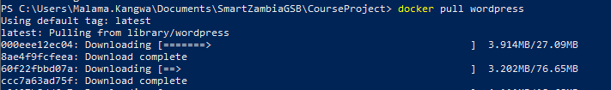image from the Docker Hub repository.

3 . **docker run [options][image]**: This command allows you to run a command inside a specified container.



4. **docker ps** : The **docker ps** command list all of the containers currently running. The **-a** option allows you to check the status of each container.

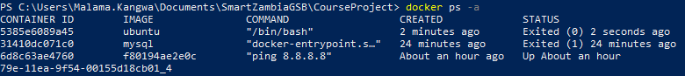

5. **docker images**: The **docker images** command lists all the images that are currently stored on the system.

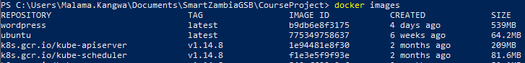

6. **docker exec -it [container] bash**: The **docker** **exec** command



7. **docker start [container_id]**: This command starts a docker container.



8. **docker stop [container]**: This command stops a docker container.



9. **docker commit [container][image]**:



10. **docker login**:



## Powershell Commands

1. **Get-ChildItem:** List all the files in the current directory.

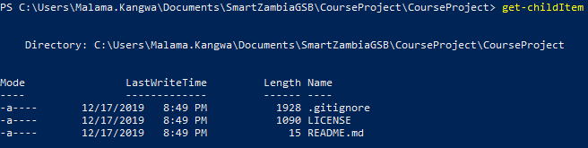

1. **Get Process:** Lists the details of all the processes.

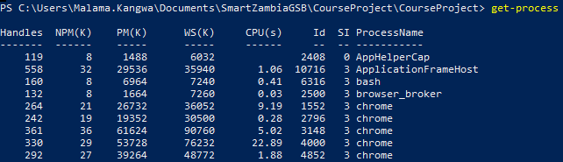

1. **Get-Service:** List the details of every service.

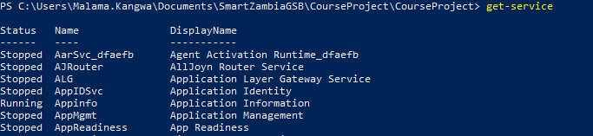

1. **Get-Process [name]:** List the details of the specified process.

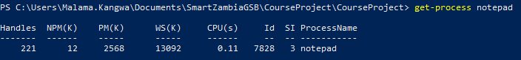

1. **New-Item [name] -ItemType [item type]:** Created a new file in the current directory.

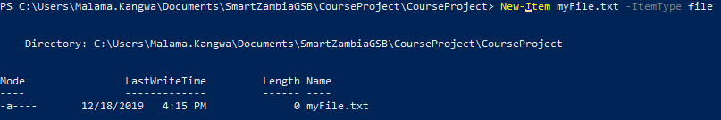

1. **Get-Command:** List the details of all the commands stored on the system.

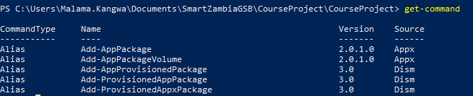

1. **Get-Help [command]:** Assists the user by providing details on a specified command.

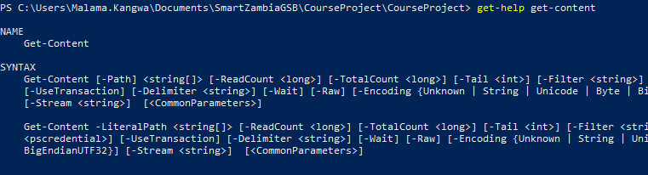

1. **Get-Content:** This command gets the content of the item at the specified location.



1. **Start-Process [name]:** Starts the specified process.

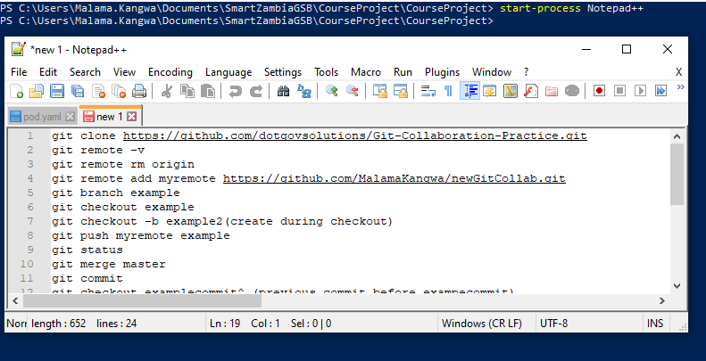

1. **Stop-Process [id]:** Stops the specified process.

